IoT Guide

Amy Topping

In this guide we will explore the IoT rig and the processes involved in setting the rig up and running a script on it to record the temperature, humidity, and date and time within the specified access periods.

Step 1

In the beginning we need to put all wires and sensors on the board, this is shown in the image below.

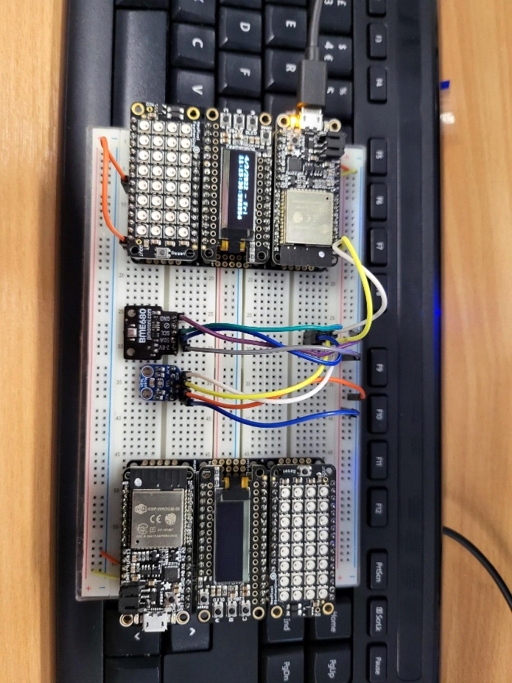

The wires must be placed on the board correctly to allow connection between components, and connection to our virtual machine we use to access the board.



The orange wire, shown via the arrow allows the neopixel featherwing to work properly, it is important wires are connected to the correct components and placed on the board in the correct positions.

In this instance there must be 5 empty squares between each end of the orange wire.

Step 2

Now, we will need to open the virtual machine on our computer, first open VMWare, and then select the ‘Windows 10 IOT’ virtual machine from the sidebar on the university computer. If you are using another PC, such as a personal one you will need to load the VM from wherever you have it saved, i.e. a memory stick.

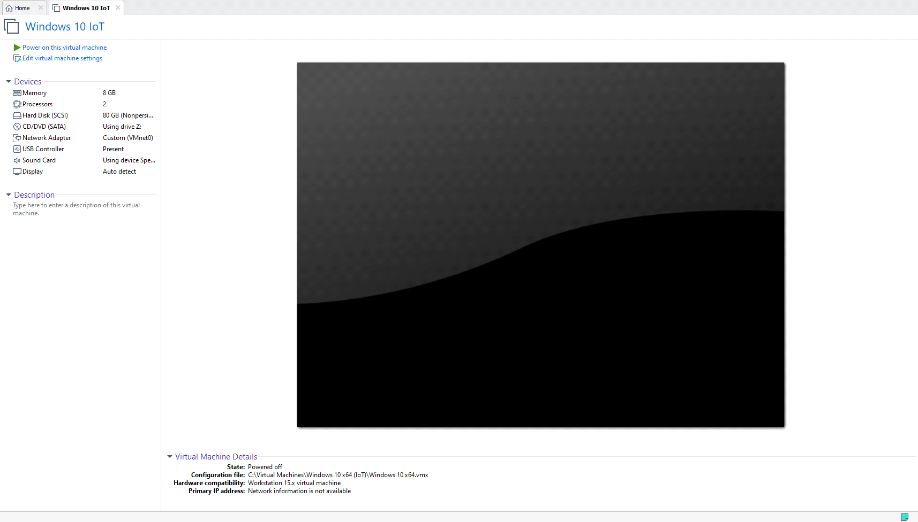

This VM is password protected, the password is ‘password’. Now, click power on Virtual machine along the side panel, shown here.



You will now be taken in to the usual Windows 10 loading screen as you are signed in to the machine.

Step 3

In this step we will connect the rig to the virtual windows 10 machine, this is done by connecting the USB A end to the PC, and the micro end to the board, shown here:

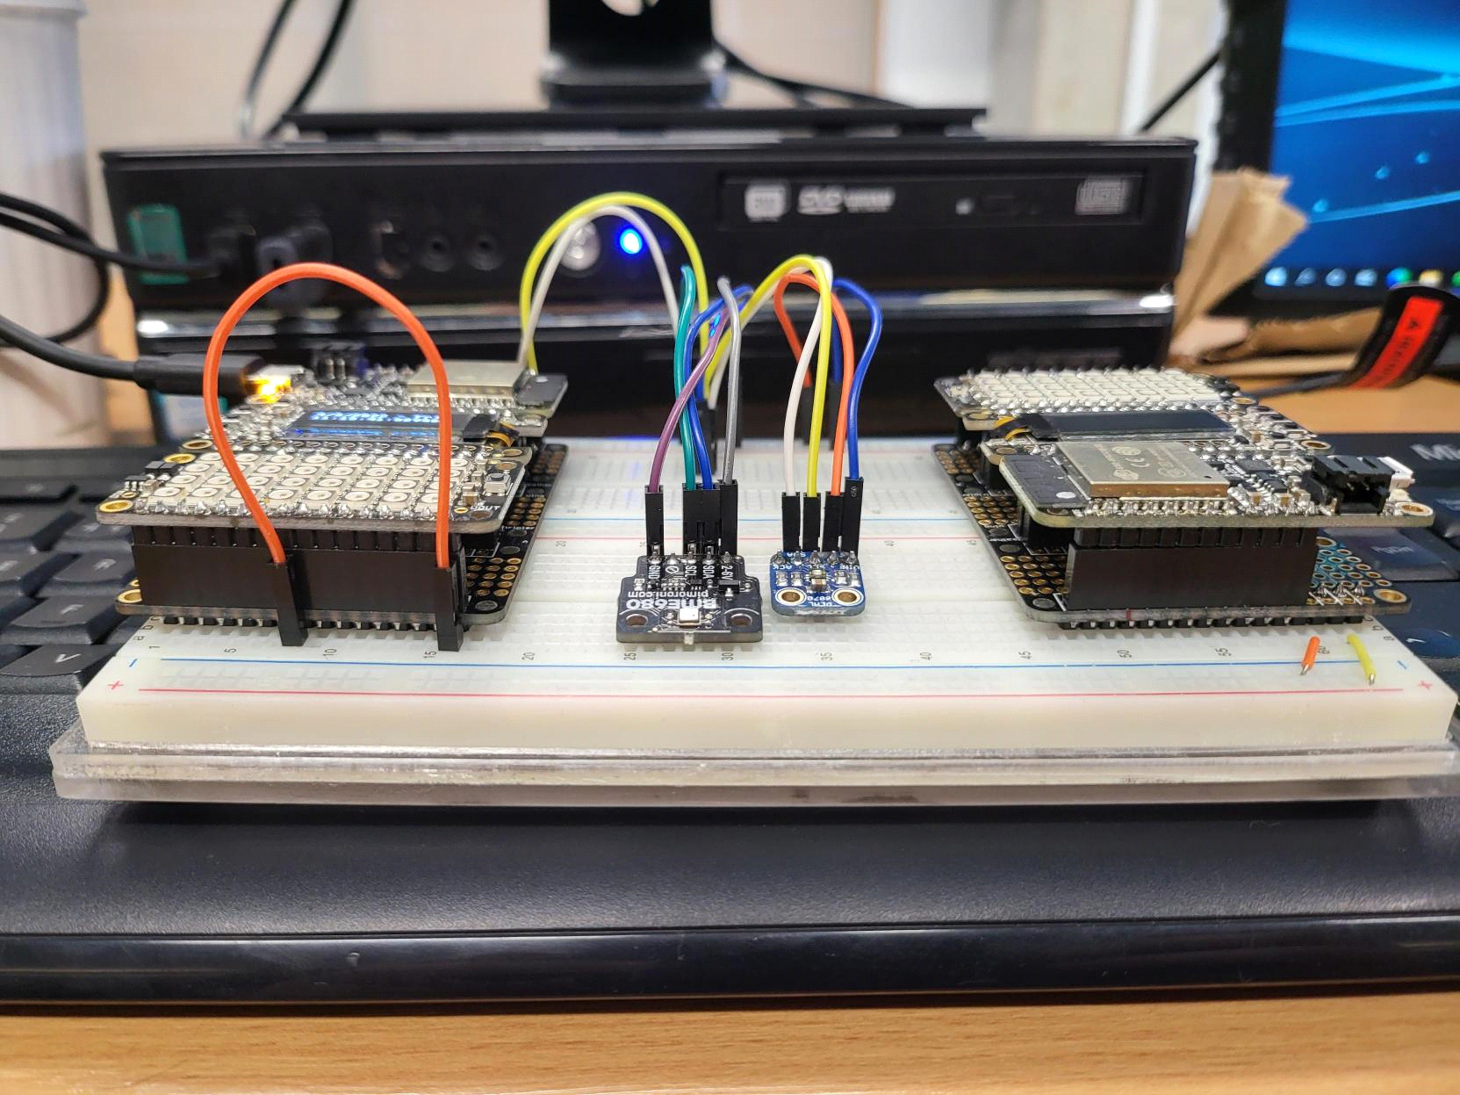

When this is done, you should receive a screen like this :

After this you must ensure that your rig is connected to the VM, to do this, go onto the USBDeview program, the icon looks like this:

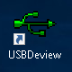

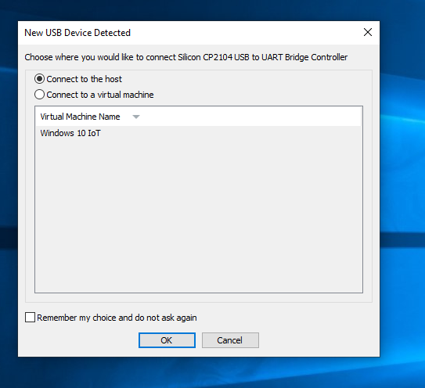Now we will see this screen come up:

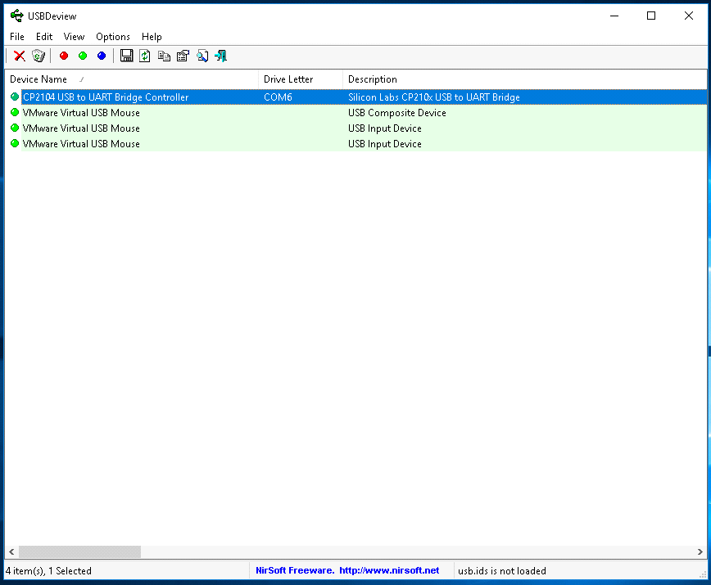

This is the USBDeview program, it is used to see all devices currently connected the PC. Cp2104 references the rig, showing it is connected to your pc. Take note of the com port you are connected to, as this is important for running code on the device. In this instance, we are connected to COM6.

Step 4

Now we need to make sure we have the required folders on our virtual machine, to do this, find them on your pc ad copy them to the VM’s desktop folder. Make sure you remember where you have them saved!

Step 5

We are now able to use CMD to start working with our rig! Simply open CMD by going on the start menu, and then typing CMD into the search box, it will show like this :

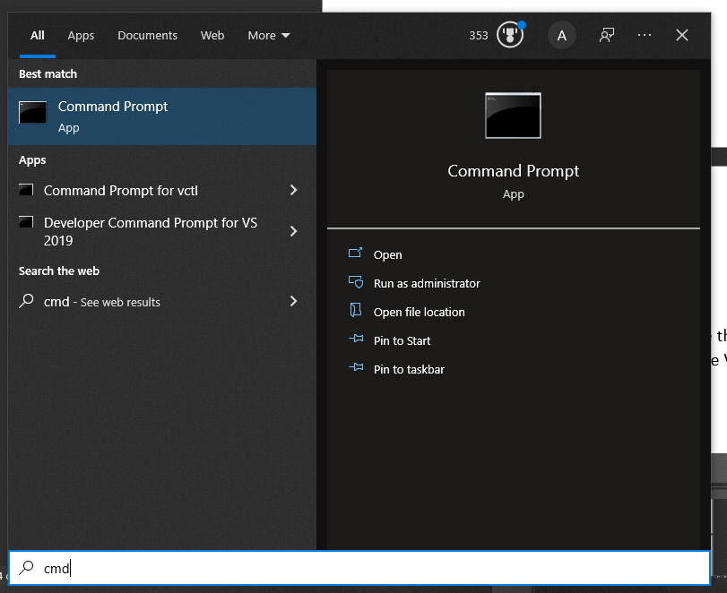

First of all, after opening CMD we must reflash the rig, this formats its memory, destroying any code that was previously left on it.

Use cd to change directory to the folder with the files you need in, as shown below:

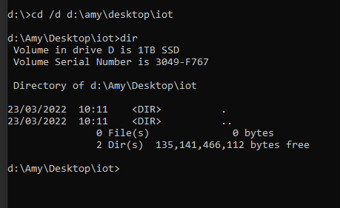

By running the dir command after we can see all files in this folder.

Step 6

To flash the rig copy this code into your CMD prompt:

ampy -p COMXX run YYYY.py

remember your com port from earlier and replace the XX with the number you were connected too. YYYY.py will be replaced by the file name of the script you wish to run on your rig.

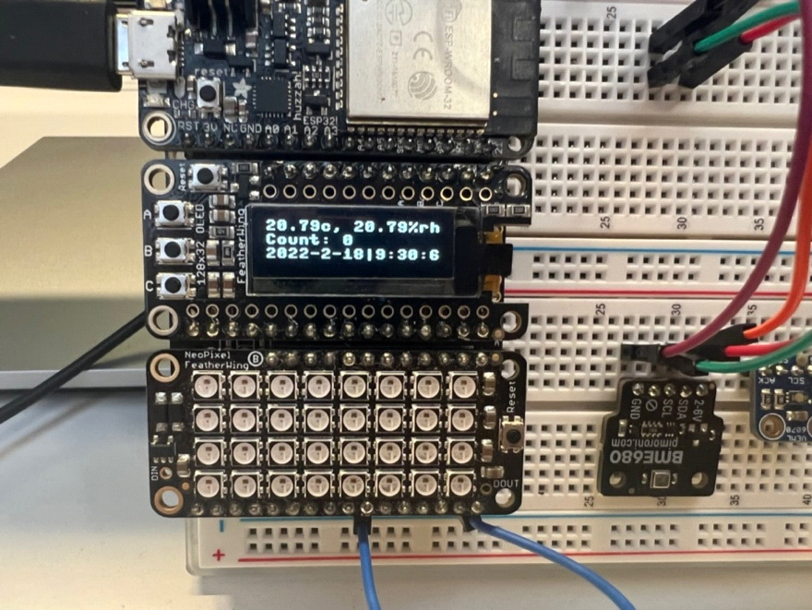You should now see things starting to happen on your rig, depending on which script you have ran, in this instance you can see the OLED screen has changed to show temperature, humidity, date, time and a counter.

Next, you will see the LED lights flashing green or red depending on if the access period is active or not.

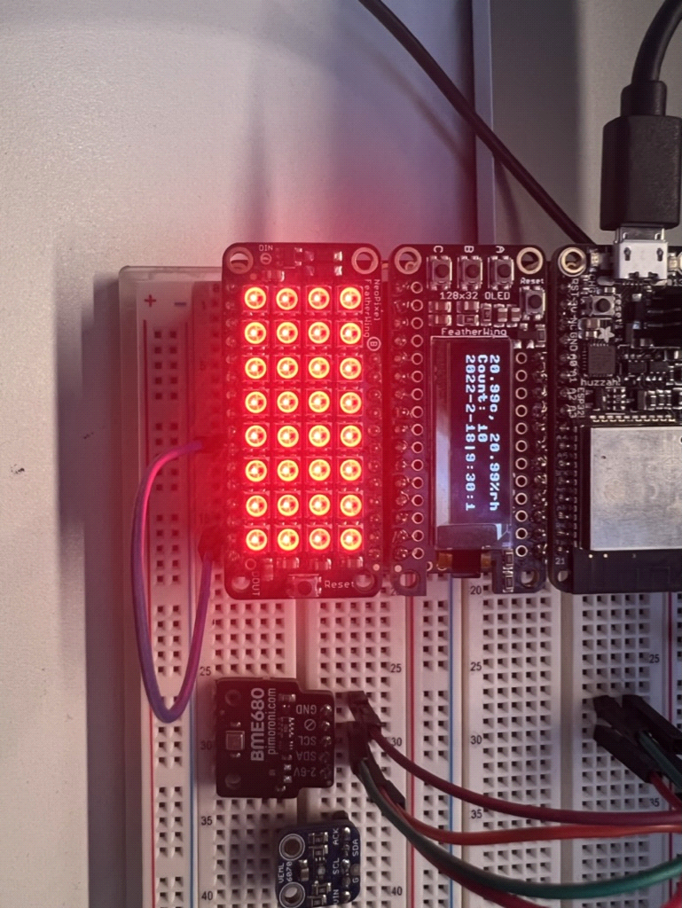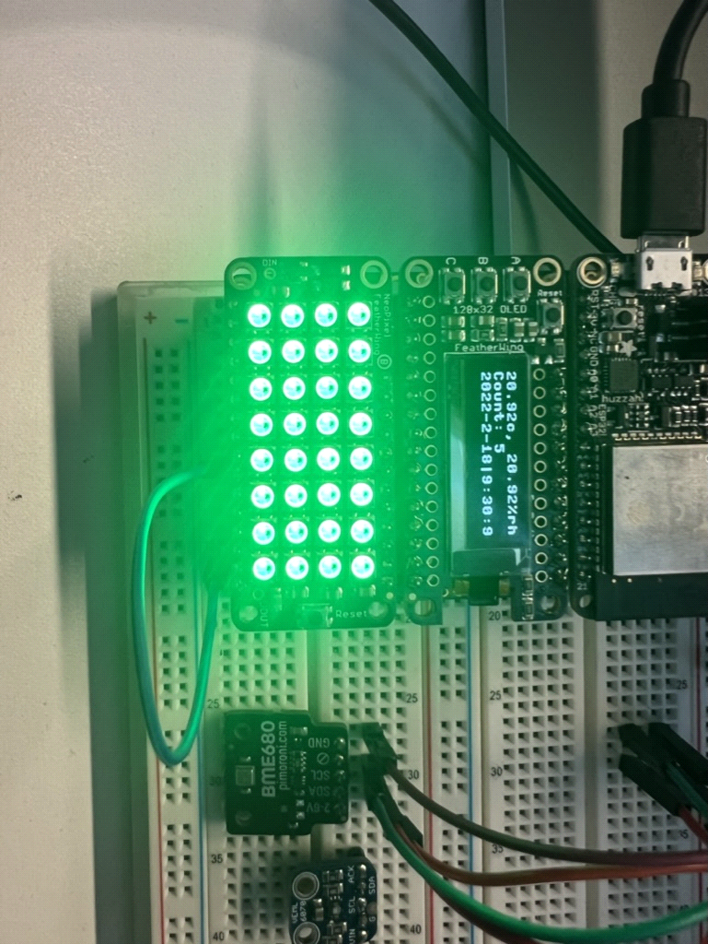

The counter on the screen starts and the access period is set to true or false after reaching 10 seconds, as defined in our script.

When you have finished collecting data, press the c button on your rig, and the command prompt will show this line of code :

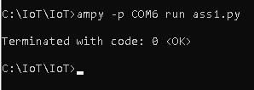

Step 7

We have now successfully set up our board and ran our script, now we must ensure the data has been collected successfully. Type this into the command prompt:

ampy -p COMXX get YYYY.csv

Again, replace the X’s with your comport number, and the Y’s with your file name. when you have ran this line, you will see your data in the command prompt window, like this: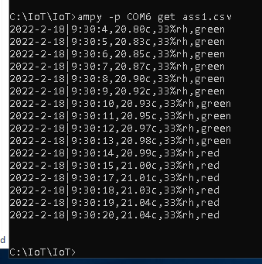

This reads the data that we recorded but doesn’t save it, we need to do this ourself by typing

ampy -p COMXX get YYYY.csv YYYY.csv

Once we have done this our data is saved into a csv file, which can be seen in the folder with your scripts.

Desktop app guide

After getting the readings from our Iot rig, and ensuring the data is saved to a csv file, we can use this application to see our results.

Make sure you remember where your file was saved as we need it now.



run this command to see the data come up on the cmd prompt from your desktop app.

